## Vi Tool Editor - Assignments

1. **Invoke the vi editor with a filename (which is to be created)**

Ans: vi text1.txt

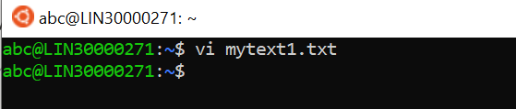

1. **Type a few lines(at least 10) in the editor. Let one or more lines contain the words given below.**

delhi mumbai chennai Mumbai

Ans:

1. press i to insert lines
2. then type few lines in vi editor consisting delhi mumbai chennai Mumbai

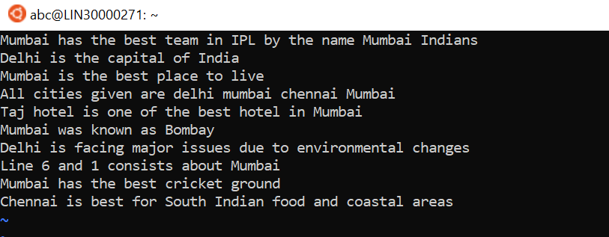

1. **Save the file without exiting the editor**

Ans:- :w

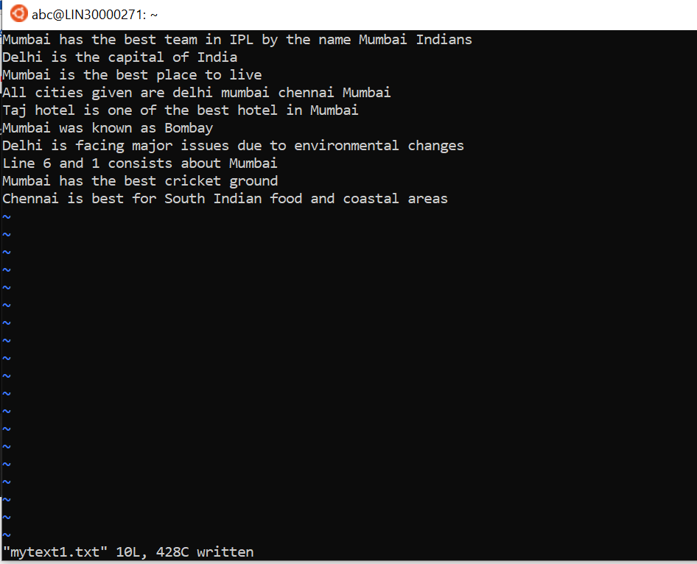

1. **Navigate quickly to the beginning & end of the file**

Ans:

1. for beginning: g or ^ or 0
2. for ending: shift+g or $

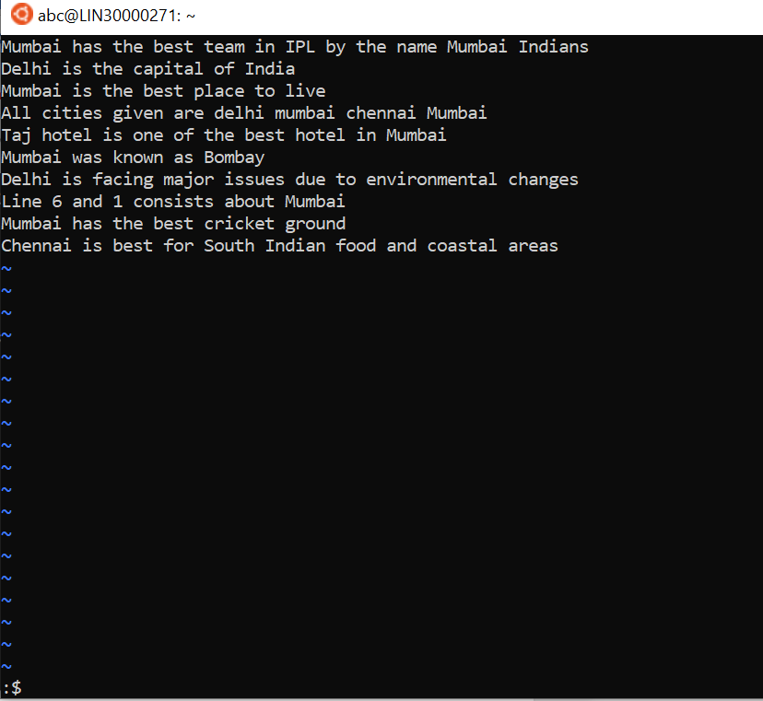

1. **Delete first two lines & copy it after the last line.**

Ans:

1. Press ESC key and enter in the command mode.
2. Place the cursor on the line you wish to delete.
3. Then execute this command for delete the 2 lines:- .2d
4. Move cursor to the last line via G command.
5. Type p to the copy it after the last line.

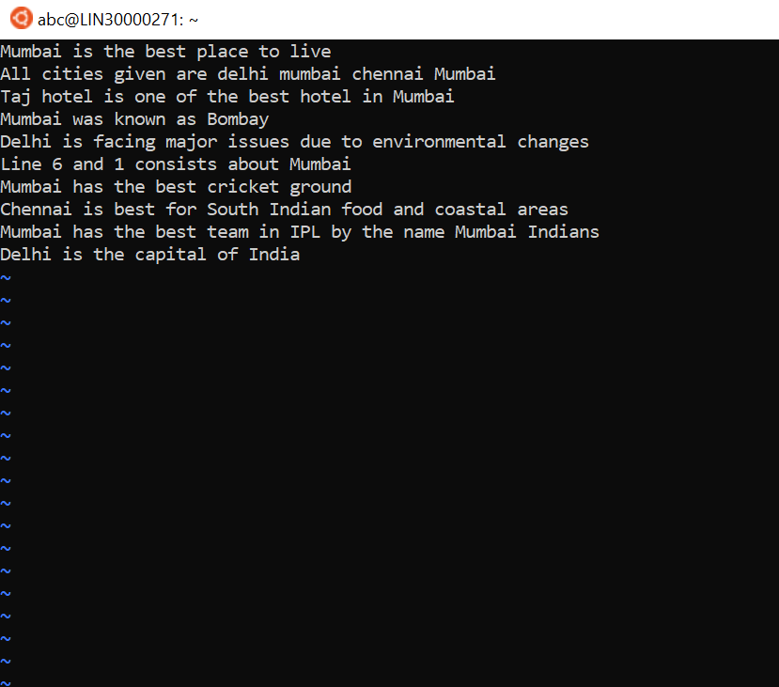

1. **Now Copy the last two lines & paste them before the first line**

Ans:

1. Place the cursor on the last line.
2. For the delete last 2 lines:- :$;-1d
3. For moving to the first line press:- gg
4. Type p to paste
5. Combine last two lines of the file in a single line.
6. Place the cursor at the line where you have join the next line

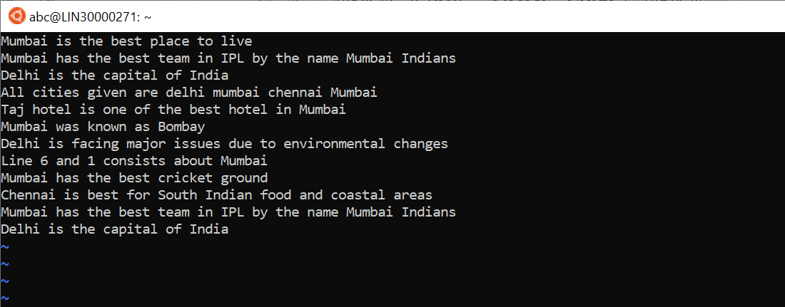

1. **Combine last 2 line of file in single line**

Ans: use J command

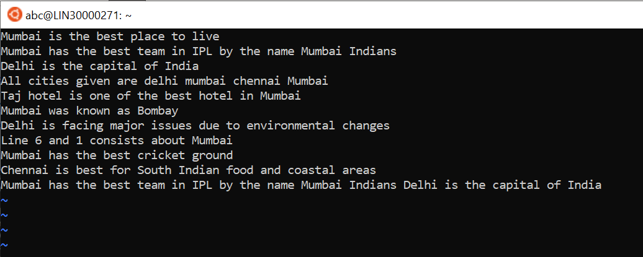

1. **How will you insert a line before the first line? (Hint : Find such an option in the tutorial document)**

Ans: go to the first line and place cursor at that location and press shift + O command to insert a line.

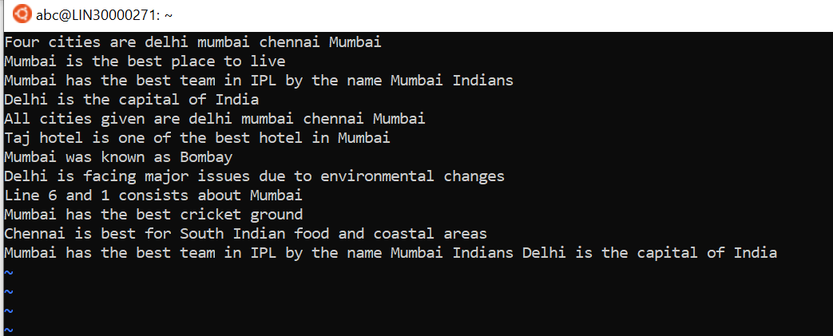

1. **How will you paste a yanked buffer before the current line?**

Ans: p

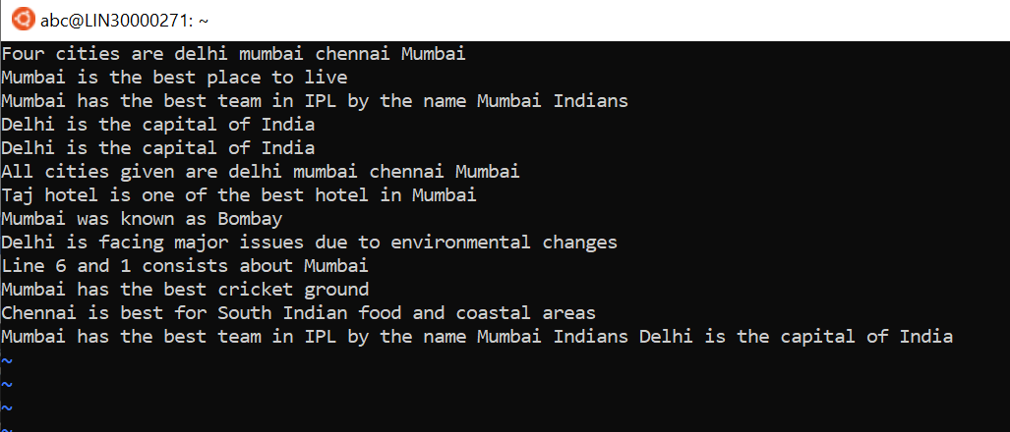

1. **Search the document for a string “delhi”**

Ans: /delhi

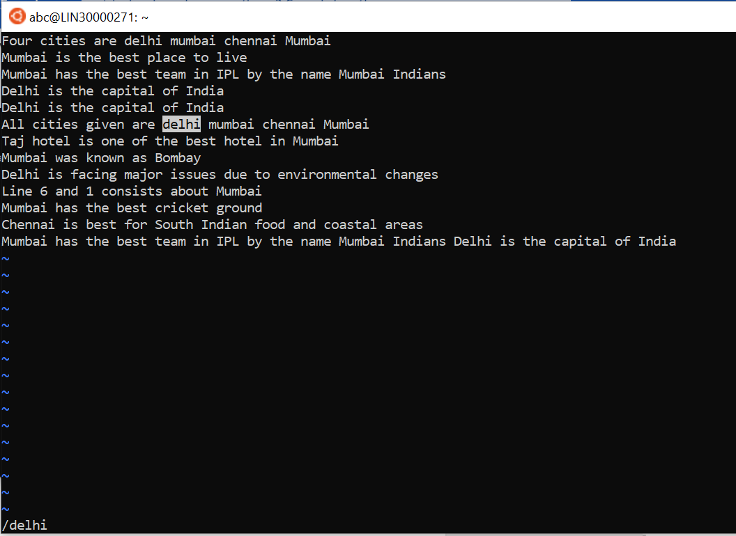

1. **Replace a single occurrence of “delhi” with “Mumbai”**

Ans: :s/delhi/Mumbai

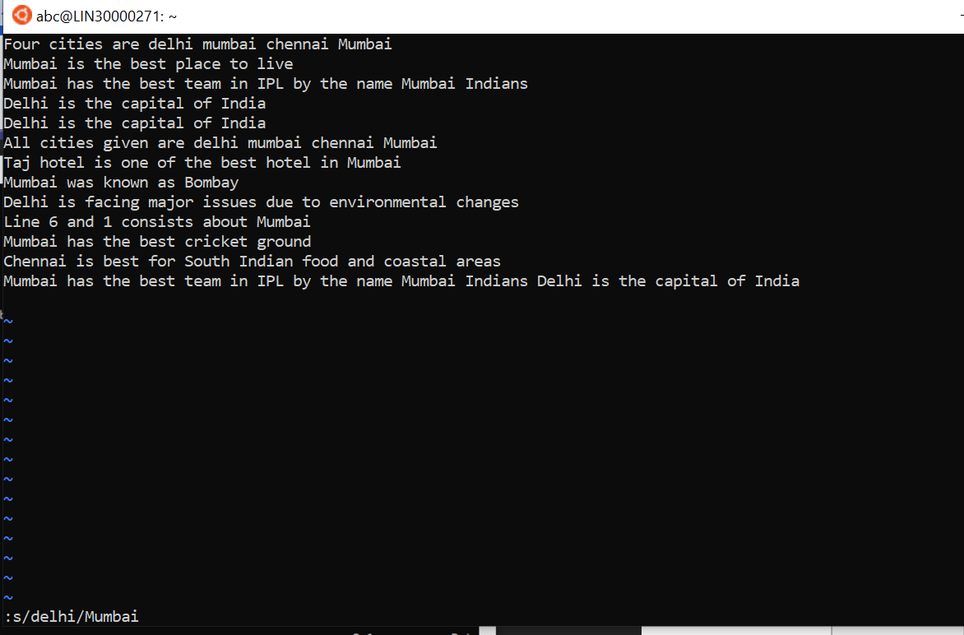

1. **Replace all occurrences of “delhi” on a particular line with “Mumbai” using one command**

Ans:- :s/delhi/Mumbai/g

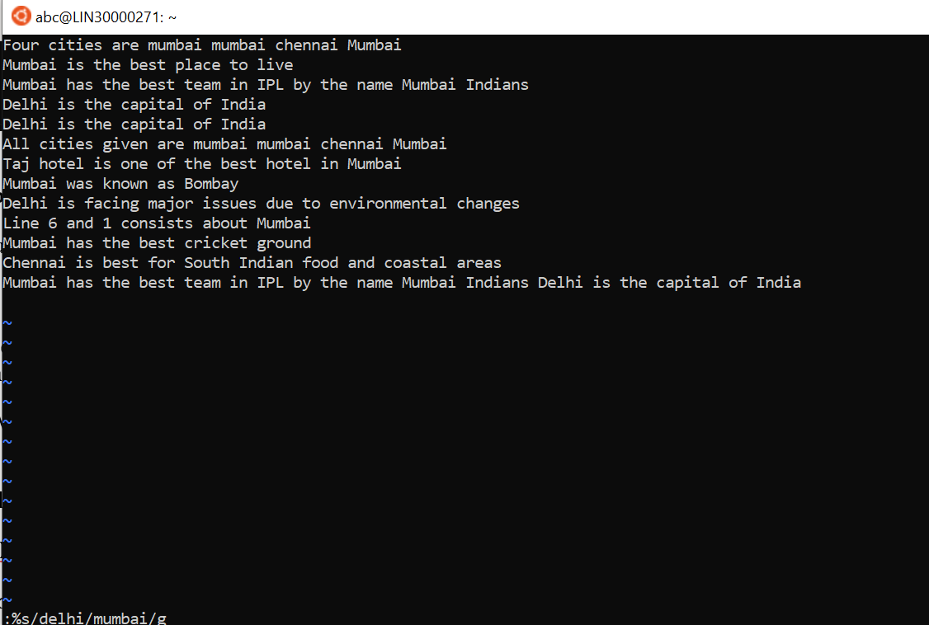

1. **Replace “delhi” with “mumbai” for the entire document using one command.**

Ans:- :%s/delhi/Mumbai/g

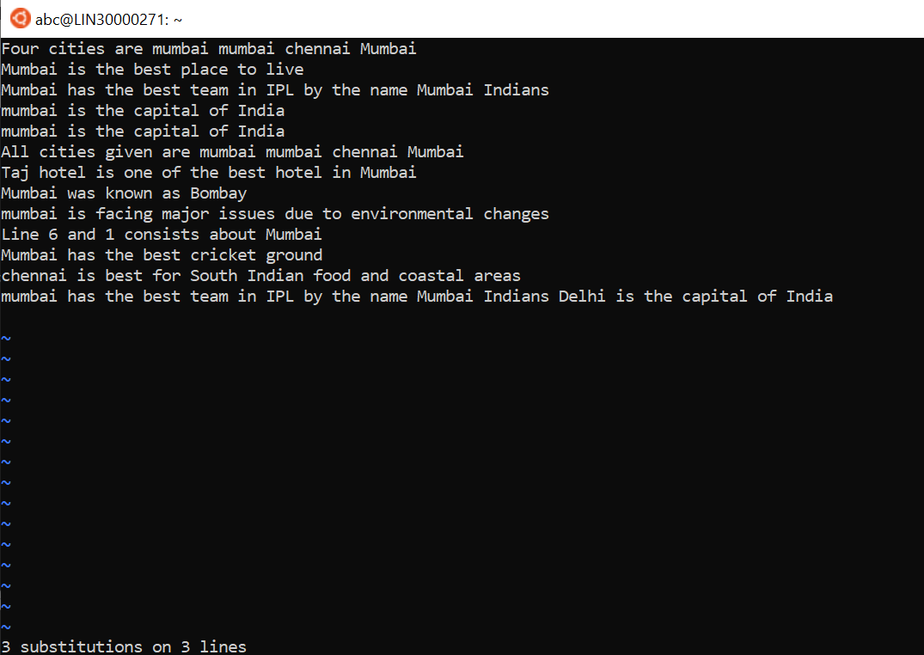

1. **Replace all occurrences of “delhi” with “mumbai” for part of a document (e.g. line number 13 to 37).**

Ans:- :4,6s/delhi/mumabi/g

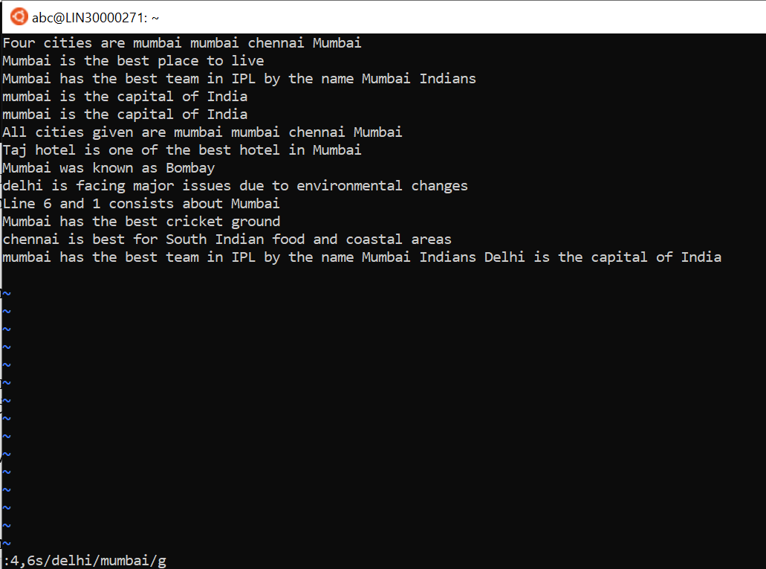

1. **Undo the above command**

Ans:- :u

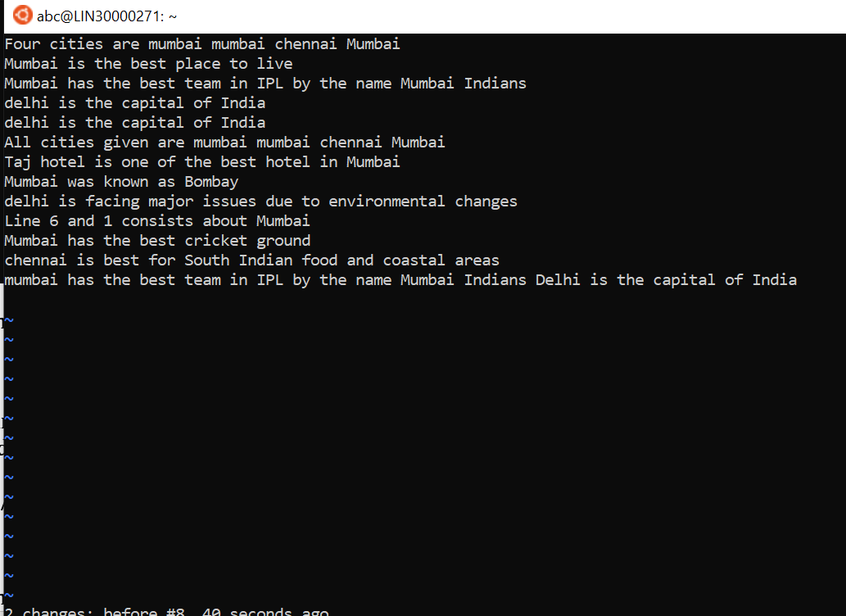

1. **Replace only the first occurrence of “delhi” with “mumbai” in each line, for part of a document (e.g. line number 13 to 37).**

Ans:- :%s/delhi/Mumbai/gc

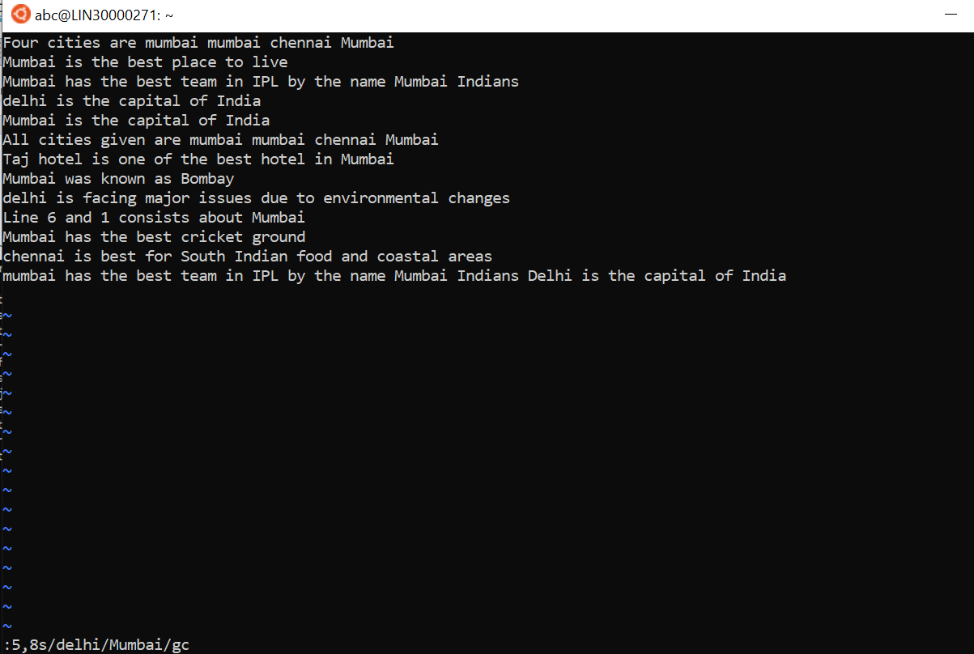

1. **Undo the above comment. Redo it. Undo it again.**

Ans:

1. For undo:- u
2. For redo:- ctrl+r.
3. Final command:- u-ctrl+r-u
4. **Replace all occurrences of “delhi” with “mumbai” for complete file interactively.**

Ans: %s/Delhi/Mumbai/g

1. **Search for a word backwards. Loop through all matches.**

Ans: ?string

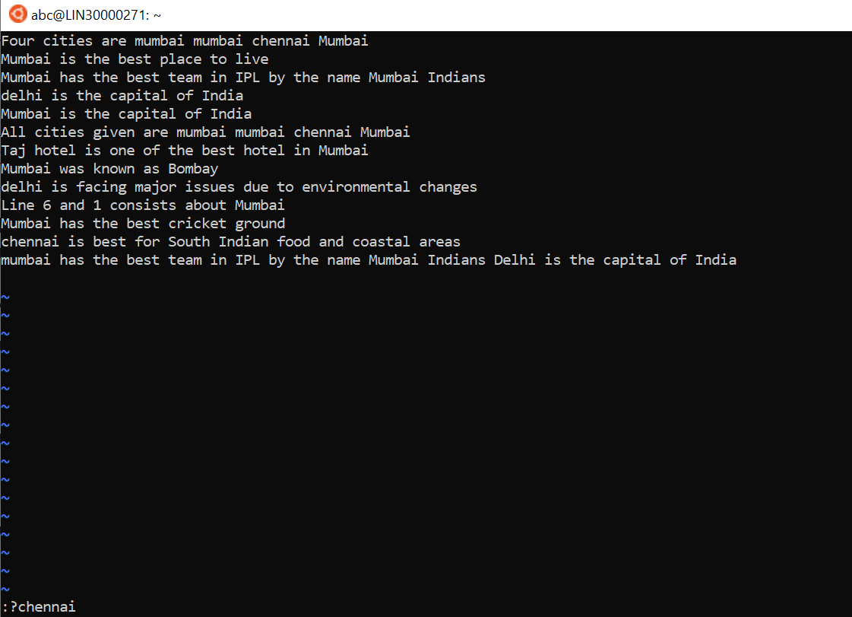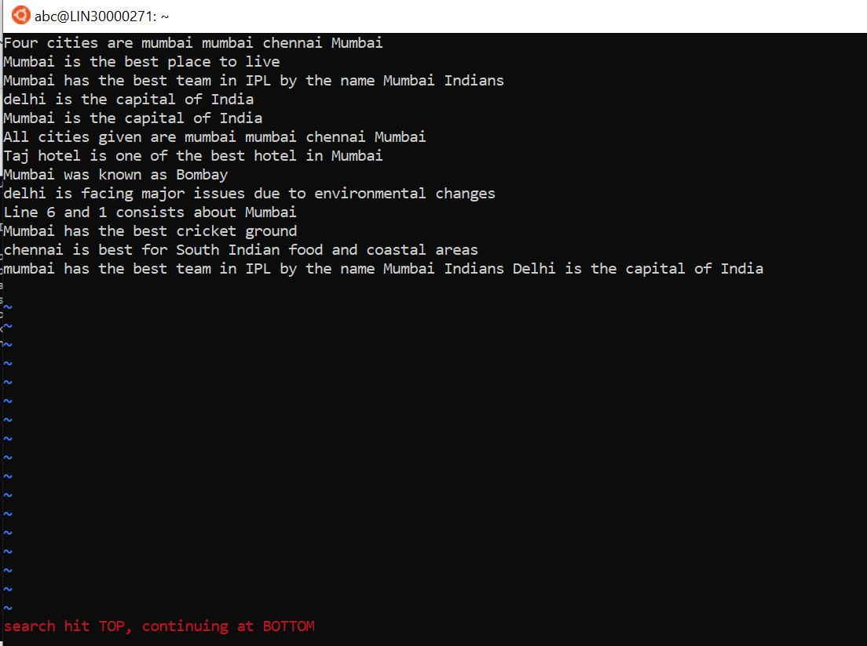

1. **Search for a word forwards. Loop through all matches\**

Ans: /string

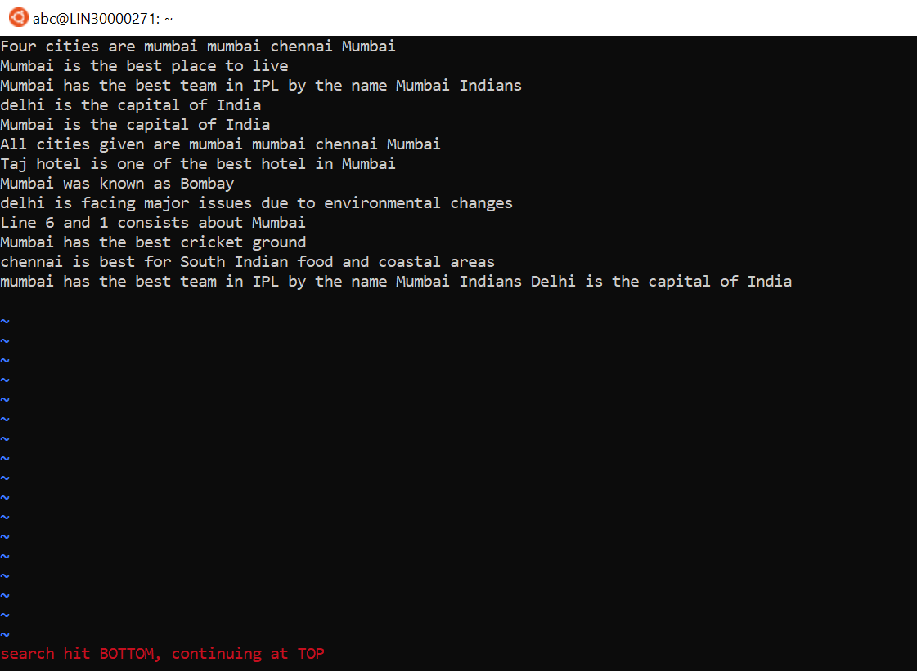

1. **Join two lines together.**

Ans: J

1. **Enable line numbering and then disable it**

Ans:-

1. :set number

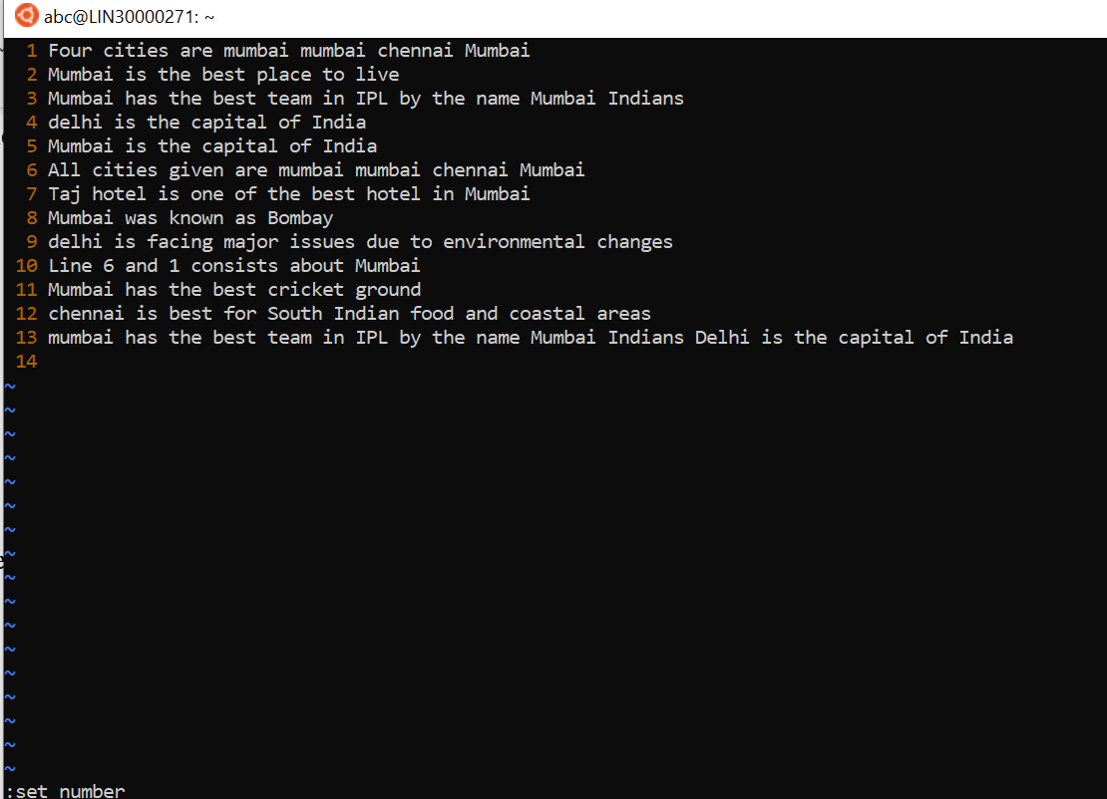

1. :set nonumber

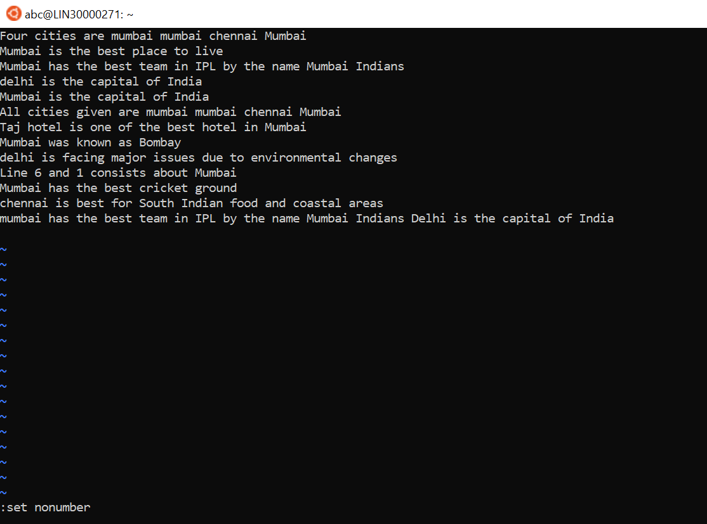

1. **Make the search case insensitive**

Ans:- :set c

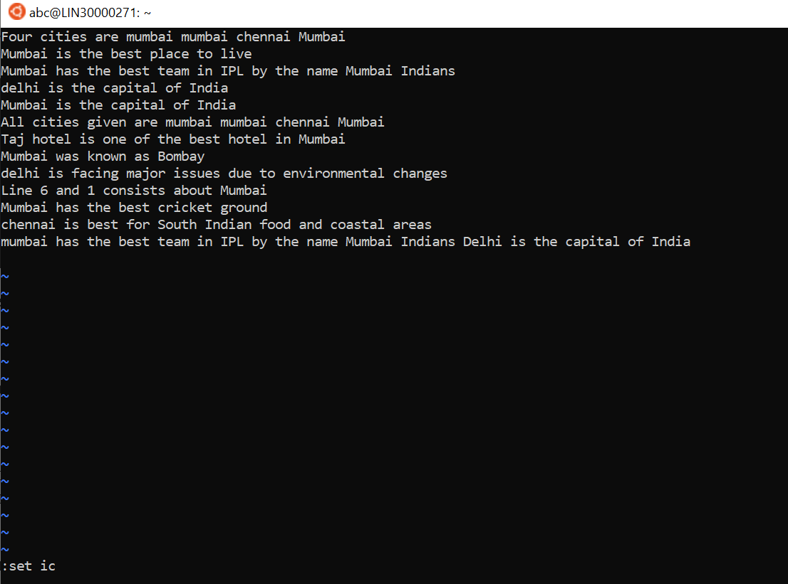

1. **Delete 4 lines (and then paste them somewhere else)**

Ans:

1. For deleting the four lines:- 4dd
2. Then place the cursor to the position and press P for paste

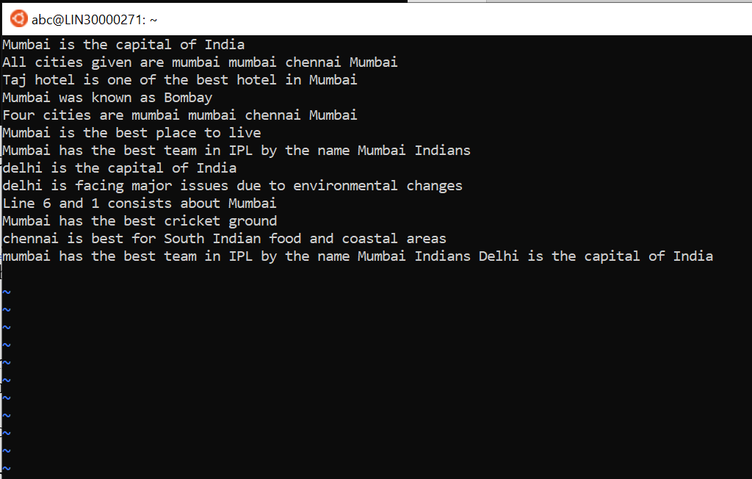

1. **What is the command to delete part of the line starting from the current cursor position?**

Ans: Place the cursor to the position and press dw

1. **What is the command to delete the current word?**

Ans: Place the cursor to the current word and press dw